SHULL SCIENCE · JAMES A. GARFIELD LOCAL SCHOOLS
UNIT 2 QUIZ B
QUIZ · VERSION B · ELECTRON CONFIGURATIONS AND IONS
NAME | DATE | PERIOD | SCORE / 23

You may use a periodic table. For multiple choice, circle one letter. In an orbital diagram, each electron gets one arrow.

Part 1 Multiple choice | 3 points

1 | Which rule says two electrons in one orbital must have opposite spins?
1 | A Aufbau principle | B Hund's rule | C Pauli exclusion | D Bohr model
2 | Which orbital diagram for oxygen's 2p⁴ follows Hund's rule?
2 | A | B | C | D
  ↑↓ | ↑ | ↑
  ↑↓ | ↑↓
  ↑ | ↑ | ↑
  ↑↓ | ↑ | ↓
3 | Which sublevel fills right after 3d?
3 | A 4s | B 4d | C 4p | D 3f

Part 2 Longhand configurations and orbital diagrams | 8 points

4 | 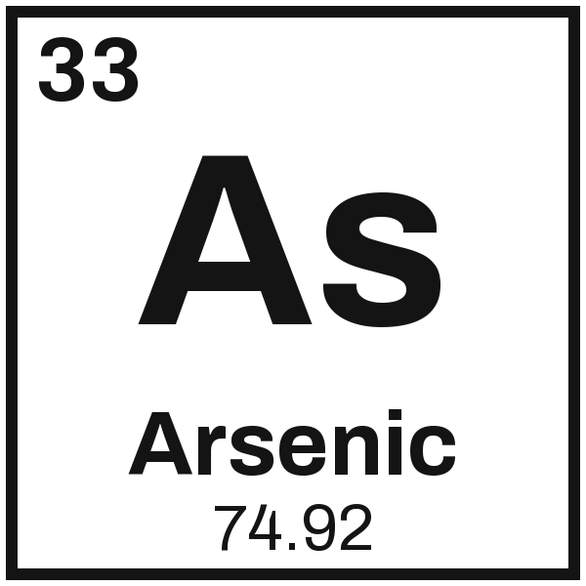 | Configuration
4 |  | Orbital diagram

5 | 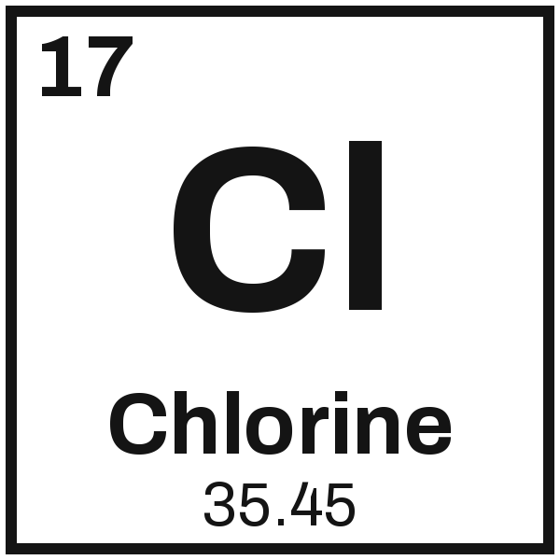 | Configuration
5 |  | Orbital diagram

Part 3 Noble-gas shorthand | 4 points

6 | 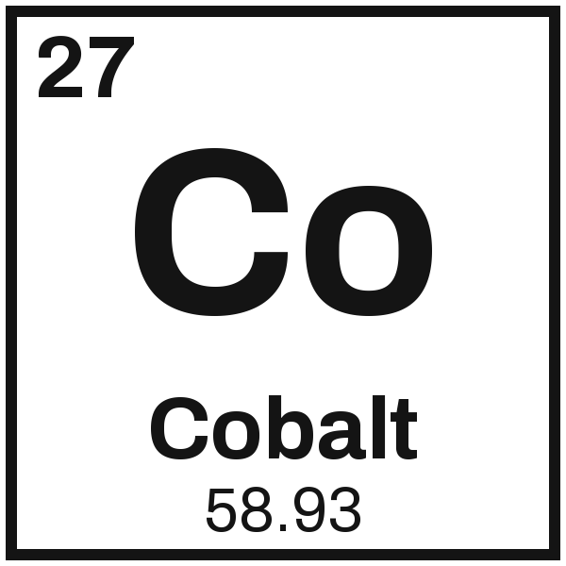 |  | 7 | 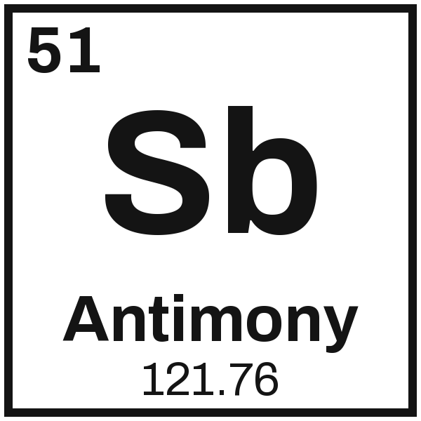

Part 4 Ions: the charge, and cation or anion | 8 points

8  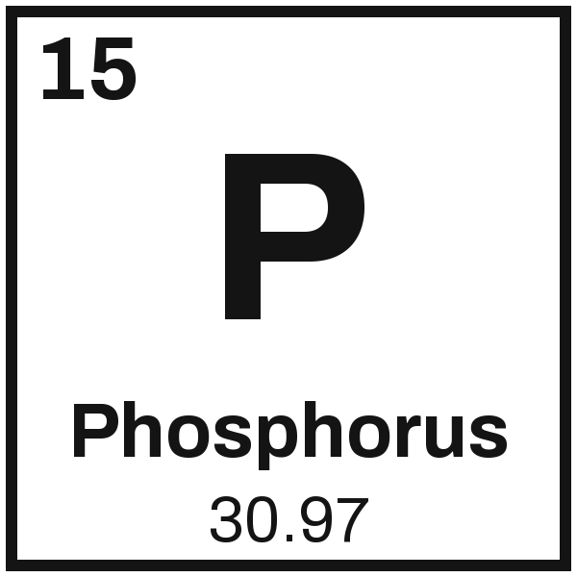  Charge _________  cation or anion | 9  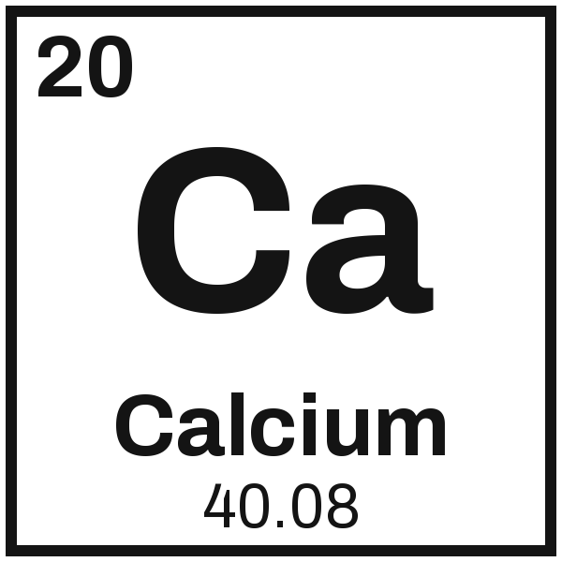  Charge _________  cation or anion | 10  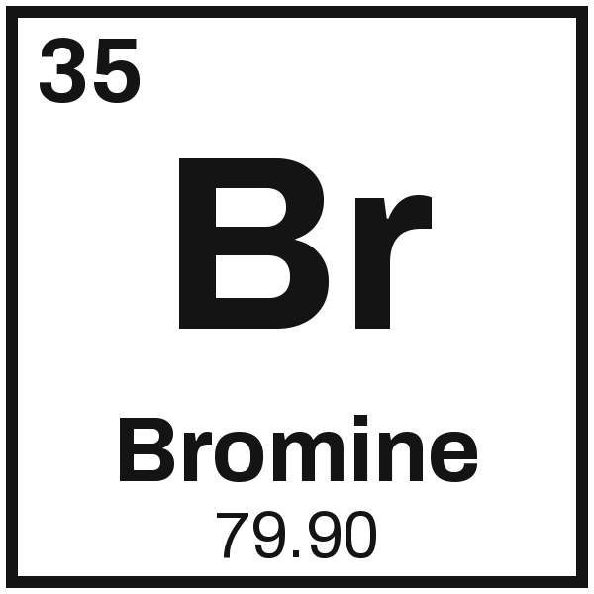  Charge _________  cation or anion | 11  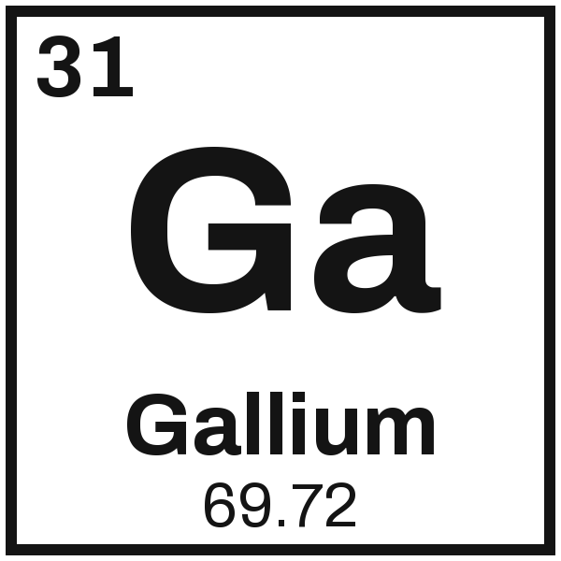  Charge _________  cation or anion

